EXPERIMENT 3

3.Create a simple cloud software application for Car Booking Reservation System using any Cloud Service Provider to demonstrate SaaS.

Aim
To develop a simple cloud-based Car Booking Reservation System using Zoho Creator as a Cloud Service Provider and to demonstrate the Software as a Service (SaaS) model for managing customer and car booking details.

Procedure
- Log in to Zoho Creator.
- Create a new application in Zoho Creator named Car Booking Reservation System.
- Create a single form named Car Booking Details and add the required customer, car, pickup, and payment fields.
- Configure suitable field types such as Name, Phone, Email, Number, Date, Time, Currency, and Drop Down.
- Add a simple workflow to calculate the Total Amount based on the price per day and number of booking days.
- Enter sample booking details, submit the form, and verify the records using the cloud application.

Implementation
The Car Booking Reservation System was implemented using Zoho Creator as the cloud service provider. A single form named Car Booking Details was created with fields such as customer name, phone number, email, car type, car model, pickup location, drop-off location, pickup date, return date, pickup time, number of passengers, price per day, number of days, total amount, payment method, and booking status. Drop-down fields were used for selecting car type, payment method, and booking status. A simple workflow was implemented to automatically calculate the total booking amount. Sample car booking records were entered and tested in the cloud application.

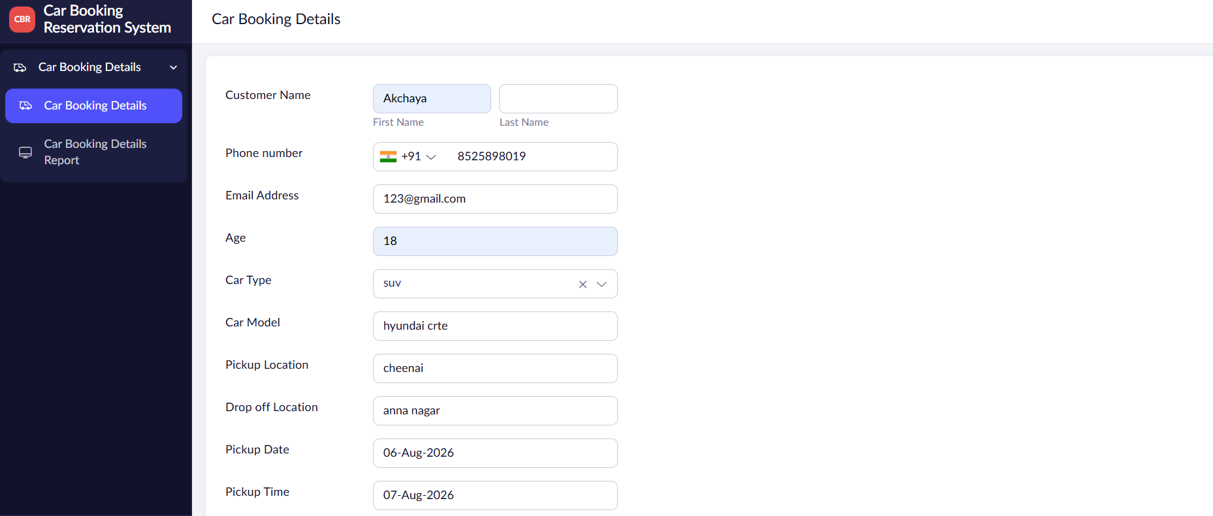

FIGURE 1:CAR BOOKING RESERVATION FORM

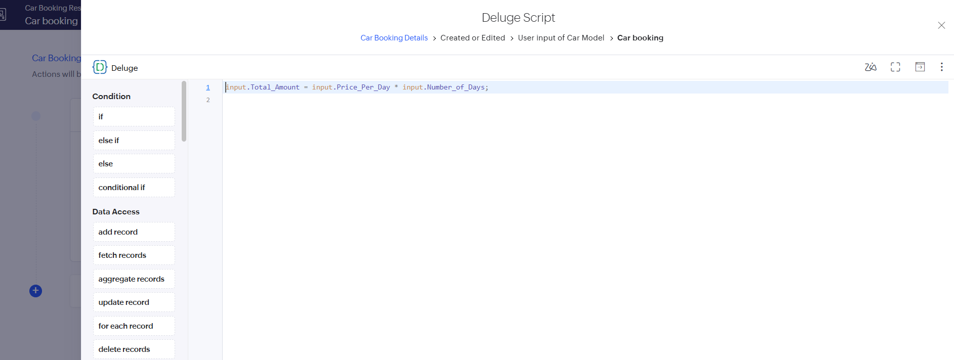
FIGURE 2: WORKFLOW

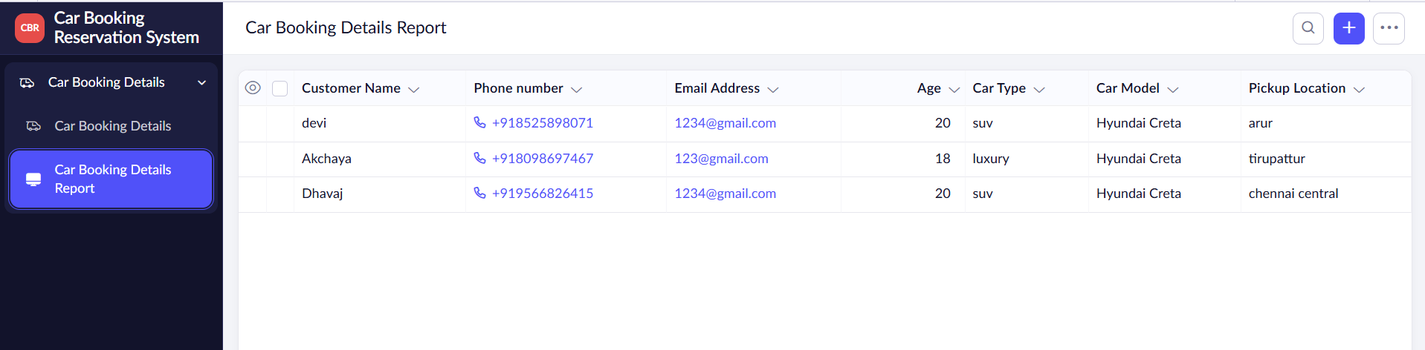
FIGURE 3: CAR BOOKING AND RESERVATION SYSTEM REPORT

Result
Thus, the Car Booking Reservation System was successfully developed using Zoho Creator. The application allows users to enter customer and car details, manage pickup and return information, calculate the total booking amount, and maintain payment and booking status. The experiment successfully demonstrated the SaaS model using a cloud-based application.

